Manual

ProSAPCONN & Kettle

Version 2.0

Table of contents

1 What is ProSAPCONN & Kettle? 3
2 Installation 3
2.1 Software 3
2.1.1 Supported platforms, operating systems 3
2.1.2 Java Runtime Environment 3
2.1.3 Kettle 3
2.1.4 ProSAPCONN as a Kettle plugin 4
2.1.5 SAP JCo 4
2.2 Firewall configuration 5
2.3 Customizing security on your SAP system 5
2.4 Customizing the SAP System for optimization 5
3 FAQ 6
3.1 PSCFAQ0001 - How to set the correct Java Runtime Version? 6
3.2 PSCFAQ0002 - How to install an updated version of ProSAPCONN without installing Kettle? 6
3.3 PSCFAQ0003 - How to get access to the SAP Service Marketplace? 7
3.4 PSCFAQ0004 – What is the maximum row size? 7
4 Errors 7
4.1 General errors 7
4.2 ProSAPCONN errors beginning with PSC 7
4.2.1 PSC0001 - Error opening the connection to the SAP System: [details] 7
5 Conversion of data types 10
6 History of changes 10

What is ProSAPCONN & Kettle?

With ProSAPCONN you can read data from all tables of your SAP system.

We provide a special plugin for Kettle - a data warehouse tool for Extraction, Transformation, Transportation and Loading of data, in short: ETTL.

All this makes data warehouses much easier to build, update and maintain. People working with ProSAPCONN find the extraction of SAP data very easy and usefull. Not only for data warehousing also for ad hoc analyses as a consultant or …

Kettle provides a graphical user interface Spoon - a user friendly designer for your transformations, also for your SAP queries over tables.

After designing your transformations let them run interactive with Spoon or in batch mode with Pan.

Installation

Software

Supported platforms, operating systems

The installation process is described for windows platforms. If you need further assistance for other platforms please let us know. ProSAPCONN & Kettle supports many different platforms.

Java Runtime Environment

You need Java 2 Platform, Standard Edition (J2SE) version 1.4 or higher. You could check if you have already installed it with:
Start / Settings / Control Panel / Add or remove programs
[German: Start / Einstellungen / Systemsteuerung / Software]

If you havn´t installed it yet, please download a version 1.4 or higher from
http://java.sun.com/j2se/ and install it.

Kettle

Unzip the Kettle zip-file in a directory of your choice, e.g. in
C:\Program files\Kettle

Try to run Spoon.bat. If it fails see the PSCFAQ0001 - How to set the correct Java Runtime Version?

For a detailed description of the installation consult the Kettle manual.

ProSAPCONN as a Kettle plugin

The ProSAPCONN plugin is delivered with Kettle. If you want to install an update version see PSCFAQ0002 - How to install an updated version of ProSAPCONN without installing Kettle?

SAP JCo

The SAP Java Connector (SAP JCo) is a toolkit that allows a Java application to communicate with any SAP System. Unfortunately the redistribution of the SAP JCo is not allowed, so you have to download it from the SAP Service Marketplace at

http://service.sap.com/connectors SAP Java Connector / Tools & Services

There you will also find all available distribution packages for the various supported platforms and processors.

If you don´t have a login for the SAP Service Marketplace ask your SAP administrator or request the data by SAP (see PSCFAQ0003 - How to get access to the SAP Service Marketplace?).

After you have downloaded the latest JCo, e.g. sapjco-ntintel-2.1.6.zip extract this to a temporary folder.

Copy the following files out of the zip archive:
Filename | Target folder
sapjco.jar | Copy to the directory plugins\steps\ProSAPCONN below the kettle path:  e.g. C:\Program files\Kettle\plugins\steps\ProSAPCONN
sapjcorfc.dll | Copy to the directory libswt\win32 below the kettle path:  e.g. C:\Program files\Kettle\libswt\win32  [This is different to the JCo documentation.]
librfc32.dll | Copy to the directory [Windows]\System32

Important note for librfc32.dll:
Please check if you have an old version of librfc32.dll in your [Windows]\System32 folder. If so please update it with the newer librfc32.dll. Sometimes this fails because the DLL is in use by another process. If so, please restart your system and don´t start the SAP GUI before you replace the old DLL.
In future ProSAPCONN releases this installation process will be more automated.

Firewall configuration

JCo uses the native RFC library with the CPI-C protocol based on TCP/IP for its low level network communication. For CPI-C you need special TCP/IP ports going through your firewall.

These ports are 3300 plus your target system number e.g. 3308 for system number 08.

For detailed information on the network configuration see the JCo documentation […]/docs/jco/configuration.html

Customizing security on your SAP system

In order to retrieve meta data information from the SAP system's data dictionary, you have to grant the access rights (Authorization Object: S_RFC, ACTVT: 16, FUGR) for the following function groups:
R/3 Release | Function Groups
since 3.1H | RFC1, SG00, SRFC, SUNI, SYST
since 4.0A | RFC1, SDIF, SG00, SRFC, SYST, SYSU, SUNI
since 4.6A | RFC1, SDIF, SG00, SRFC, SYST, SYSU
since 4.6D | RFC1, SDIFRUNTIME, SG00, SRFC, SYST, SYSU

For requesting the data we use RFC_READ_TABLE or a customized RFC that belongs to the function group SDTX. So you have to grant the access rights (Authorization Object: S_RFC, ACTVT: 16, FUGR) also to SDTX.

If you want to have security on table level (and not only on table groups as the default) see section “Customizing the SAP System for optimization”.

Customizing the SAP System for optimization

You should customize a special RFC (Remote Function Call) for

- adding security to the table level (and not only on table groups) and

- giving better performance on table queries exceeding 512 bytes of row width.

- using floating point values and special numerical values

ProSAPCONN is automatically determining the capability of the SAP system and uses a customized RFC if it is available. If it uses the default RFC_READ_TABLE it runs automatically multiple queries to get the needed data exceeding the 512 bytes boundary. So more overhead is there and if data changes between queries you possibly get wrong data. There are some internal tests getting the right data but we recommend using the customized RFC.

We show you how to customize it:

Create a new Function Group

RFC_READ_TABLE belongs to the function group SDTX.

Go to transaction SE38 and copy SAPLSDTX:

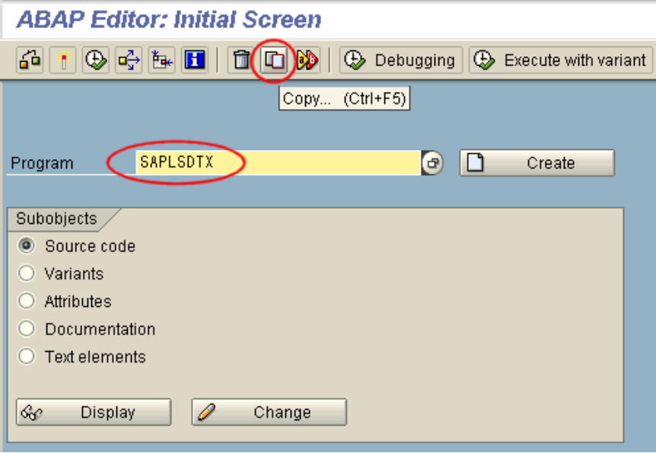

Choose ZPSCSDTX as the new function group name (PSC stands for ProSAPCONN):

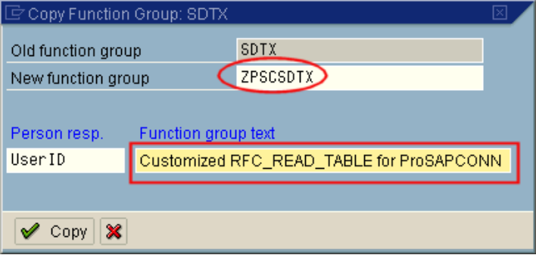

Choose a development class (ZZZZ in our Example) and save:

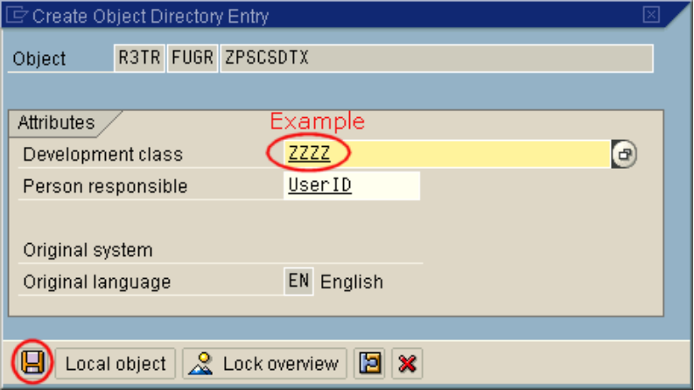

Choose a request and continue:

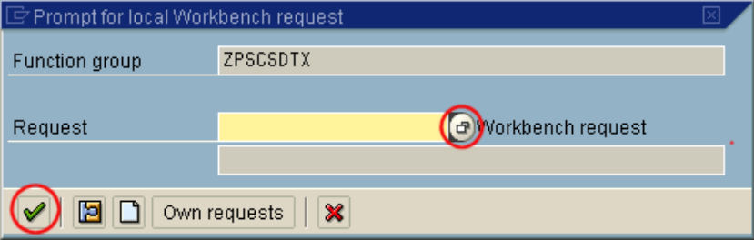

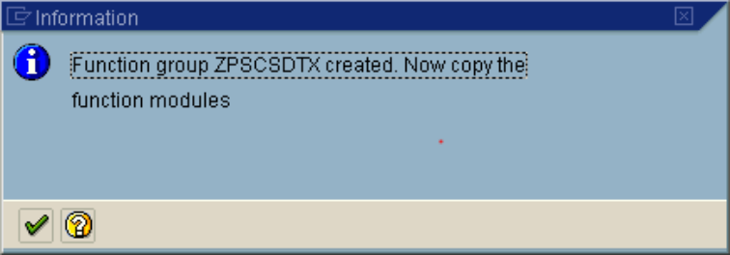

The program name of the function group is SAPLZSDTXPSC

Introduction - first steps

Spoon – the graphical user interface of Kettle

Start Spoon.bat
###picture (all pictures in XP Style !!!)
If you´re asked for “Select a repository” press “No repository” (Remark: you can save your work in XML files – later on you can use repositories)
###picture
###pictures of demo,license?

For a detailed description of Spoon consult the Kettle manual.

Setting up the connection
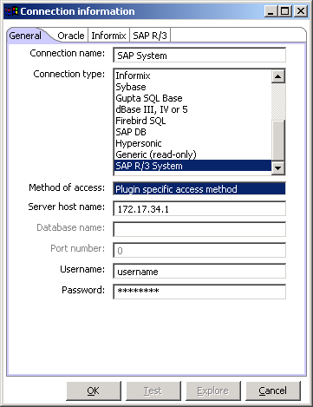
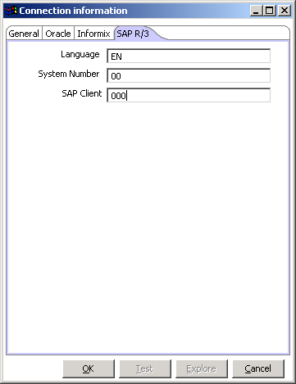

Entering the ProSAPCONN (trial) license code

Example: Query the customer data table KNA1

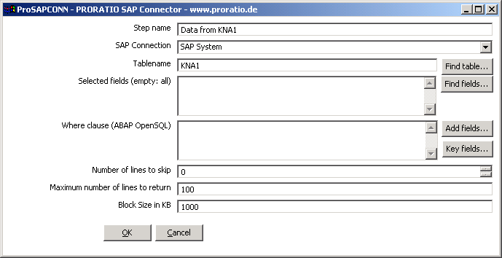

Example: Using the Mini-SAP-Basis-System (MBS) Flight Model Data

The flight model data is a data model generated by a program called S_FLIGHT_MODEL_DATA_GENERATOR. This program is specially created for the book Keller, Krüger: ABAP Objects. Galileo Press 2003. (see www.galileo-press.de)
If you have this book and the Mini-SAP-Basis-System you could use this data model.

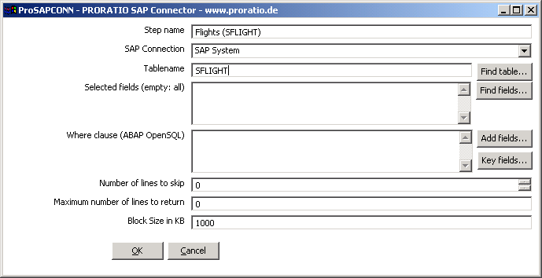

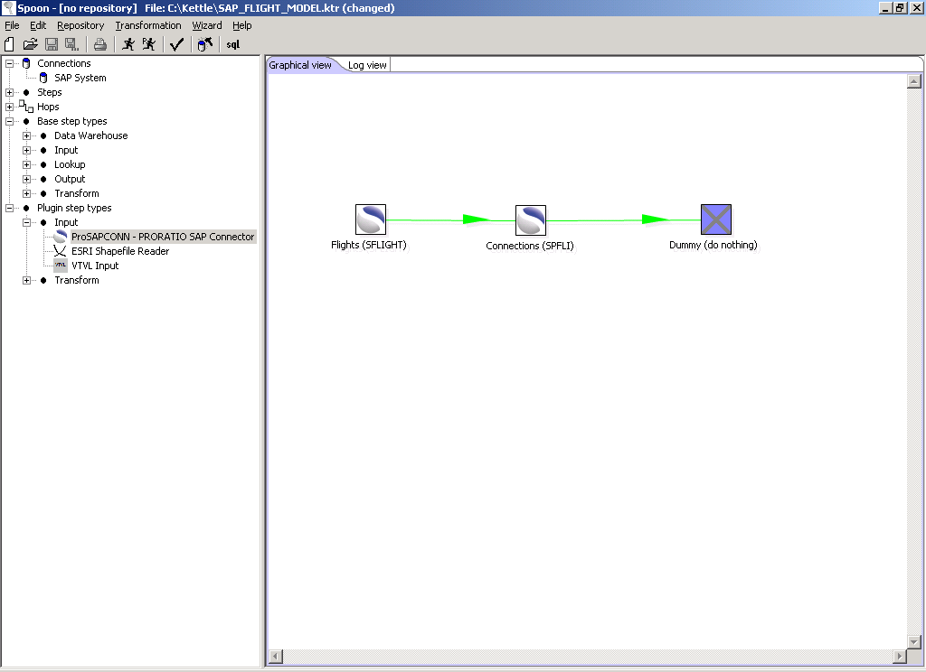

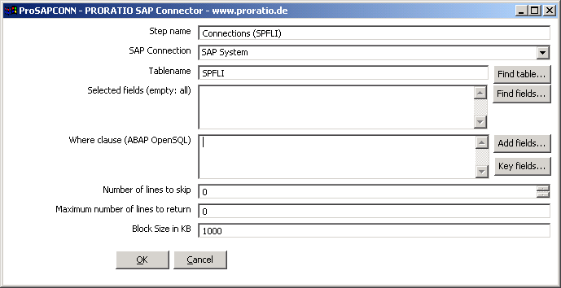

Press “Key fields” to automatically find the relational keys.

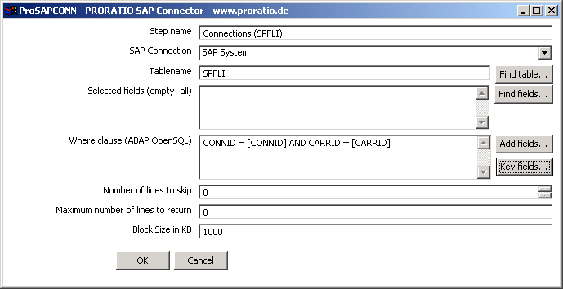

Reference

Finding tables

Look up (left outer join)

Some examples for where clauses (ABAP OpenSQL)

FAQ

PSCFAQ0001 - How to set the correct Java Runtime Version?

If you get an error like “Registry key 'Software\JavaSoft\Java Runtime Environment\CurrentVersion' has value 'x.y', but '1.4' is required.” you probably have installed different Java versions or not the needed one (you can check it with running the command “java –version”).

If you havn´t installed it yet, please download a version 1.4 or higher from
http://java.sun.com/j2se/ and install it.

Set the correct path (remember it from the Java installation) in the .bat files like Spoon.bat etc. and change the line:

REM set PATH=C:\j2sdk1.4.2_01\bin;.;%PATH%
to
set PATH=C:\your java path\bin;.;%PATH%

PSCFAQ0002 - How to install an updated version of ProSAPCONN without installing Kettle?

Unzip an updated ProSAPCONN.zip in the directory plugins\steps\ProSAPCONN below the kettle path:
e.g. C:\Program files\Kettle\plugins\steps\ProSAPCONN

The following files should be there:

Filename | Description
plugin.xml | Kettle plugin meta data
ProSAPCONN.jar | ProSAPCONN kernel
ProSAPCONN.png | ProSAPCONN logo
ProSAPCONN-Kettle.jar | ProSAPCONN Kettle plugin

PSCFAQ0003 - How to get access to the SAP Service Marketplace?

If you have a valid S-User (OSS) or SAPNet user account you could use this. If you don´t have a login for the SAP Service Marketplace ask your SAP administrator or request the data if you have an installed SAP GUI:

- Start SAP GUI and log on
- In the menu choose System / Status and get the installation number
- Start http://service.sap.com
- Select “New user? Register here!” or similar
- Enter your data with the above installation number
- You will get an E-Mail from SAP with the login data

PSCFAQ0004 – What is the maximum row size?

The maximum row size is limited to 32.000, so all queries should fit in this. The limitation of the default RFC_READ_TABLE (512) is overridden be the special query solution of ProSAPCONN. Better performance is given by doing the customizing described in section “Customizing the SAP System for optimization”.

Errors

General errors

Registry key 'Software\JavaSoft\Java Runtime Environment\CurrentVersion' has value 'x.y', but '1.4' is required.

see FAQ “PSCFAQ0001 - How to set the correct Java Runtime Version?”

ProSAPCONN errors beginning with PSC

PSC0001 - Error opening the connection to the SAP System: [details]

Detail message: You are not authorized to logon to the target system (error code 1).

This error inidicates that you reached the system but were denied permission to logon. Possible reasons for this:

1) Either your username or password is incorrect (mind the password is case sensitive). You should double check that they are correct.

2) For some other reason (i.e. wrong password entered 3 times) your account was blocked by R/3. Your R/3 admin would need to unblock it. But if you can attach to this system with the SAPGUI, then this isn't the issue.

3) Your user account does not allow a connection except with the SAPGUI. Check with R/3 admin to see if you have RFC access.

Detail message: Connect to SAP gateway failed […] ERROR partner not reached […] ERRNO 10060,ERRNO TEXT WSAETIMEDOUT: Connection timed out

There is no response from the server. Please check your network configuration (also see Installation / Firewall configuration).

Detail message: User X has no RFC authorization for function group SYST [RFC1,###***]

###***

PSC0002 - JCo seems not to be installed correctly (see installation documentation for details): [details]

PSC0003 - Meta data could not be read: [details]

PSC0004 - Next block of table data could not be read: [details]

PSC0005 - Error getting table fields for table: [details]

PSC0006 - Error reading step information from XML node: [details]

PSC0007 - Error reading step information from the repository, id_step: [details]

PSC0008 - Error saving step information to the repository, id_step: [details]

PSC0009 - Error getting connection properties for connection: [details]

PSC0010 - Wrong SAPCONN_KERNEL_VERSION: [details]

PSC0011 - Internal error: databasesList is null.

PSC0012 - Table data could not be read: [details]

PSC0013 - RFC function not available: [details]

PSC0014 - No RFC function available for row size: [details]

PSC0015 - Key fields could not be read: [details]

PSC0016 - Please select a valid SAP connection.

PSC0017 - Field name exceeds maximum length: [fieldname]

PSC0018 - The following part of the where clause exceeds maximum length: [part of the where clause]

PSC0019 - Lookup value for field name not found in previous step: [fieldname]

PSC0020 - Closing 'quotation mark' is missing in the where clause: [part of the where clause]

PSC0021 - Closing [square bracket] is missing in the where clause: [part of the where clause]

PSC0022 - Error reading rows from previous step for lookup: [details]

PSC0023 - Lookup fields are defined, step is NOT receiving fields from previous one.

PSC0024 - Step is receiving fields from previous one, lookup fields are NOT defined.

PSC0025 - Query is splitted in multiple queries due to limited row size of your RFC_READ_TABLE. One of the queries returned an unequal number of rows, so there could be changes to the SAP source table between the queries. To solve this issue we recommend to use a larger row size of your RFC_READ_TABLE. See documentation for further information.

PSC0026 - WARNING: Query is splitted in multiple queries due to limited row size of your RFC_READ_TABLE. The performance could be bad and there could be changes to the SAP source table between the queries. To solve this issue we recommend to use a larger row size of your RFC_READ_TABLE. See documentation for further information.

PSC0027 - Field size exceeds maximum length due to limited row size of your RFC_READ_TABLE. To solve this issue we recommend to use a larger row size of your RFC_READ_TABLE. See documentation for further information. Fieldname: [fieldname]

PSC0028 - Internal error - endless loop detected. For a cicumvention of this issue we recommend to use a larger row size of your RFC_READ_TABLE. See documentation for further information.

PSC0029 - Step initialization failed: [details]

PSC0030 - The following connection property is not defined: [details]

PSC0031 - The table name is empty.

PSC0032 - Error reading rows: [details]

Conversion of data types

The following table lists the conversion from SAP data types to Kettle types. The JCo data type is shown for completeness and is used internally. You can check the data types if you right click on a step and choose “Show output fields”. In the columns “Step origin” you will see the field description followed by [JCo data type/Kettle data type].

SAP data type | JCo data type | Kettle data type
ACCP | DATE | STRING (length 8, YYYYMMDD)
CHAR | CHAR | STRING
CLNT | CHAR | STRING (length 3)
CUKY | CHAR | STRING (length 5)
CURR | BCD | NUMBER (see DEC, needs CUKY)
DATS | DATE | STRING (length 8, YYYYMMDD)
DEC | BCD | NUMBER (maximum length 31)
FLTP |  | NUMBER (significance 16 digits)
INT1 | INT1 | INTEGER (0 to 255)
INT2 |  | INTEGER (-32767 to 32767)
INT4 | INT | INTEGER (-2177483647 to 2177483647)
LANG |  | (length 1)
LCHAR |  | (not allowed in where clause)
LRAW |  | (not allowed in where clause)
NUMC | NUM | STRING (only digits, fixed size,'0' padded)
PREC |  | (length 2)
QUAN | BCD | NUMBER (see DEC, needs UNIT)
RAW
TIMS | TIME | STRING (length 6, HHMMSS)
UNIT |  | (length 2 or 3)
STRING | - | - not used in SAP database tables -
RAWSTRING | - | - not used in SAP database tables -
VARC |  | (not allowed in where clause)

History of changes

Program releases

Date | Category | Changes

Documentation

Date | Category | Changes

